Student Name: Davinder Verma

Oracle UserID: dbs211_203c33

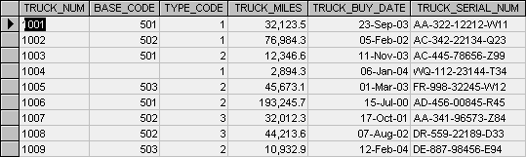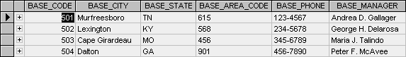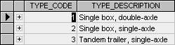
Table name: TRUCK
Table name: BASE
Table name: TYPE

- Identify the primary keys for each table.

Table TRUCK :- TRUCK_SERIAL_NUM
Table BASE :- BASE_CODE
Table TYPE :- TYPE_CODE

- Identify the foreign keys for each table (if any).

Table TRUCK :- BASE_CODE, TYPE_CODE

- Draw the entity relationship diagram.

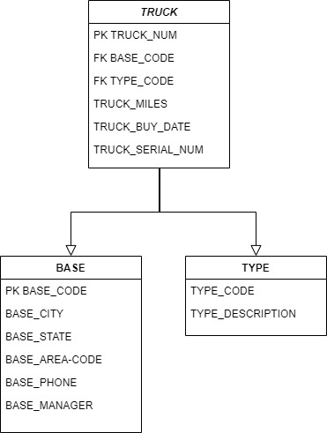

- Please list all truck_serial_num from base_city Lexington.

AC-342-22134-Q23
AA-341-96573-Z84
DR-559-22189-D33

